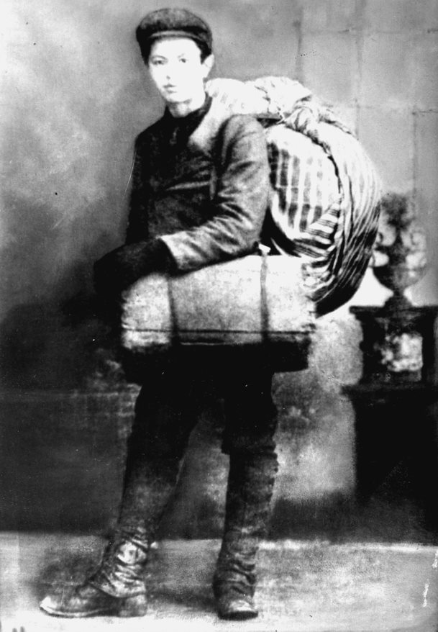
Announcing auditions for
Six Songs from Ellis
produced by
Repertory Dance Theatre

Directed by Marsha Knight and Leigh Selting
Choreographed by Marsha Knight
Asst. Choreographer: Dan Higgins

Repertory Dance Theatre is seeking 4-6 actors of all genders, races, and ethnicities to join their company in a full evening dance/theatre production entitled Six Songs from Ellis, based on oral histories of immigrants and refugees who passed through Ellis Island. This production will include audio from oral histories woven into actor text, entwined with dance/movement, and significant projection elements and music true to the individual’s country of origin. All ages (18+) are encouraged to audition, and significant movement skills are preferred. An original piece that involves both actors and dancers in cooperative roles, actors will be heavily incorporated into this script–based dance/theatre piece, which details the stories of over 80 oral histories from immigrants who passed through Ellis Island.

WHEN:

March 19th, 2020 (Thursday)

12noon-5:00pm
6:00pm-9:00pm

March 20th, 2020 (Friday) CALLBACKS

5:30pm-7:00pm movement
7:00pm-9:00pm acting

PLEASE SIGN UP FOR AN AUDITION SLOT HERE:

WHAT:

- Please bring headshot and resume.
- Please present a 90 second monologue of your choice.
- Followed by your choice of one audition excerpt from the script: see link here ??????? (this need not be memorized)

WHERE:

Rose Wagner Performing Arts Center; Studio A (lower floor)
138 West Broadway
Salt Lake City, UT 84101

COMPENSATION:

$359 per week, non-union

DATES:

Rehearsal

July 6th through August 7th 11:00am-4:00pm (weekdays, 1 hr. lunch)
September 21st through 25th 11:00pm-4:00pm (weekdays, 1 hr. lunch)

Tech/Performance

Sept. 27th through October 3rd. (days/evenings, times TBD)

Questions?

Contact Leigh Selting 307-760-0415

